THE EL PATIO HOTEL

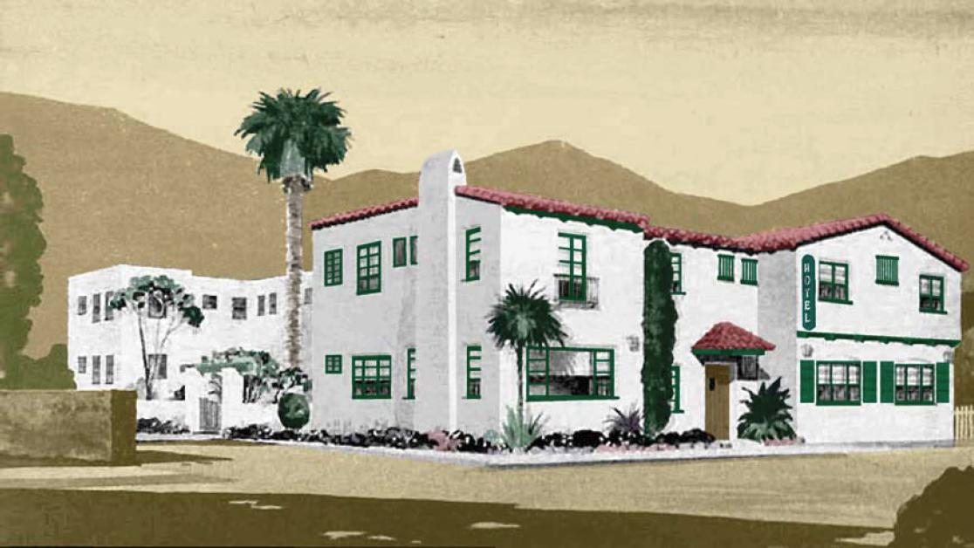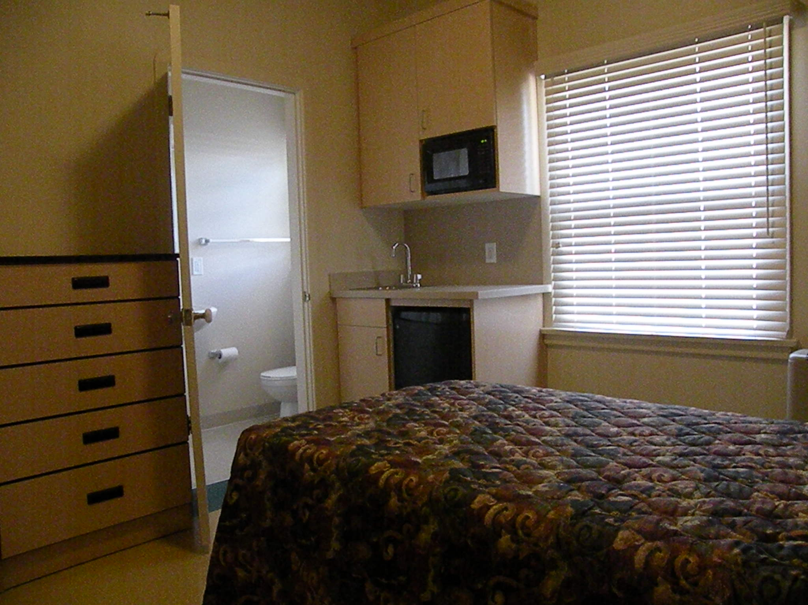

NOW RENTING
El Patio Hotel
Under New Management
Affordable Private Rooms
with bath and kitchenette

Sponsored by
Peoples’ Self-Help Housing

Eligibility for occupancy
Maximum income: One Person $24,280
Section 8 vouchers accepted

Applications are available at:

El Patio Hotel Lobby
167 S. Palm St.
Ventura Ca 93001

