L.A. NowCalifornia: This just in
LOCAL L.A. Now

L.A. council declares shelter crisis in effort to help the homeless
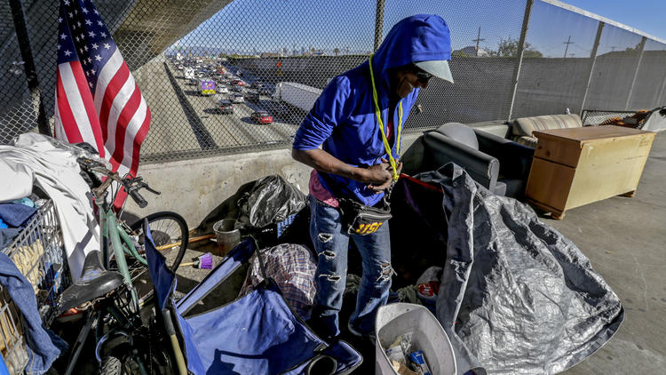
Alice Walton and Gale HollandContact Reporters
With an estimated 26,000 people calling Los Angeles sidewalks, cars and storm drains home, city officials on Tuesday approved an expanded campaign to help the homeless this winter by opening public buildings as temporary shelters and allowing people to sleep inside vehicles in designated lots.
The move comes as Los Angeles’ homeless population has multiplied across the region and Southern California is expected to be hit by severe rainstorms and possible flooding from El Niño, which could put unsheltered residents at increased risk.
See the most-read stories this hour >>
The City Council also approved what members said were changes to soften a controversial law allowing authorities to seize individuals’ property stored on sidewalks and in alleys, though opponents said the new language continues to criminalize homelessness.
It also moved to create a special fund to tackle the problem, examine ways to expand voluntary storage facilities and push for creation of a homelessness czar.
But the council did not declare a state of emergency, as members had pledged to in September, and it acknowledged that it could be weeks or months before people living in the streets see the benefits of Tuesday’s actions.
City Councilman Mitch Englander, who represents the West Valley, warned that critics would see the votes as “a Band-Aid solution to a major problem where every organ in the body is failing.”
“They will say that, and they’re right,” he added. “We have to take measures to move forward, and these aren’t huge measures.”
For many years the council has declared a “shelter crisis” from Nov. 1 to March 31 so homeless people have a place to stay during the cold winter months. On Tuesday, the council voted 14 to 0 to ask the city attorney to draft an ordinance extending the crisis further into the spring, without setting an end date. The measure will also allow council members to identify additional buildings in their districts where homeless people could sleep.
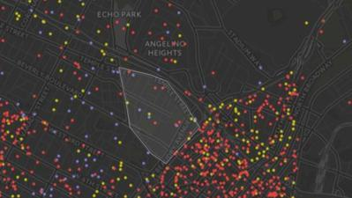
Where are L.A.'s homeless? Almost everywhere.
For the thousands of homeless individuals who live in vehicles, the city will explore allowing overnight parking in public and private lots. Santa Barbara operates a similar program, which limits the number of RVs in any one lot and provides bathroom facilities for the temporary residents.
It’s unlikely that the overnight parking program will be implemented before the end of the year, Westside Councilman Mike Bonin said.
Officials said they hope that a state of emergency, which is more often associated with natural disasters such as floods and wildfires, could make the city eligible for additional state and federal funds. But only Mayor Eric Garcetti has the authority to make such a declaration.
“I think we absolutely need it,” said Councilman Jose Huizar, recalling that when Garcetti joined seven council members two months ago to back an emergency declaration, Huizar envisioned setting up a triage center on skid row.
“I don’t understand how any emergency response unfolds in slow motion,” said Gary Blasi, a retired UCLA law professor and homelessness researcher now working with Public Counsel’s Opportunity Under Law program.
City officials declared homelessness emergencies twice in the 1980s. In June 1987, an emergency was declared in order to establish a temporary campground downtown for the homeless. Six months later, cold weather prompted a second local emergency, according to a report from the city attorney’s office.
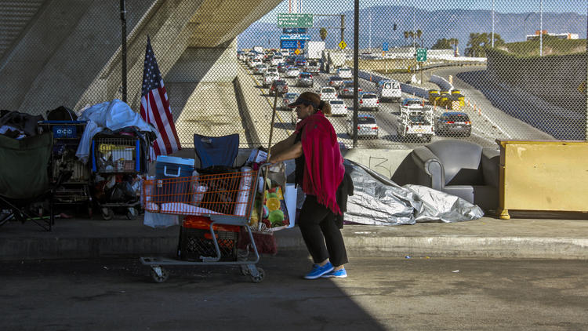
With an estimated 26,000 people calling Los Angeles sidewalks, cars and storm drains home, city officials on Tuesday approved an expanded campaign to help the homeless this winter by opening public buildings as temporary shelters and allowing people to sleep inside vehicles in designated lots.
(Irfan Khan / Los Angeles Times)
A lack of affordable housing prompted San Diego to declare a local emergency in 2002. The emergency declaration has been renewed every two weeks since then, but “it is unclear what benefits if any San Diego received from declaring the local emergency,” the report said.
The council is expected to take up homelessness again in January, when members receive a strategic plan from the homelessness committee. That plan is being developed in conjunction with Los Angeles County.
SIGN UP for the free California Inc. business newsletter >>
“The situation citywide is so grave, even if they lose a little bit of confidence at some point, their feet will be held to the fire by all the communities experiencing what we’ve been experiencing for a while,” said Carol Schatz, president and chief executive officer of the Central City Assn. of Los Angeles.
Council members heard an hour of passionate testimony from residents and activists before voting.
“It’s not something that we haven’t been dealing with for 40 or 50 or 60 years, except that it’s worse,” said Judith Hirshberg. “In my nice neighborhood, we have people who have no place to sleep, come into vacant homes and set fires. It’s not a good idea.”
On the Streets: An ongoing video series about homelessness in Southern California
Speakers complained of having encampments pop up near their homes, leading to fears of robberies, drug abuse and prostitution.
“Every time we get the alleyway cleaned up, they come right back. It’s like cleaning the house for them,” said Carol Crawford.
Over the summer, the council passed a law allowing authorities to seize homeless people’s possessions if they were being stored in public spaces.
On Tuesday, the council voted to ask the city attorney to limit the actions that would be considered unlawful under the controversial ordinance.
Homeless people would have to comply with a lawful order from any city official to take down their tents during the day, and store their belongings in city storage facilities if they are available within a two-mile radius. The city attorney’s spokesman said violators could be ticketed, fined or arrested on misdemeanor charges.
The council also asked city staff to report back on expanding its voluntary storage capacity for homeless people, which is currently limited to skid row.
“City Council moved forward with the amendments that I requested, ensuring that our streets are clean and safe without criminalizing the most vulnerable,” Garcetti said in a statement. Earlier, he allowed the measure to become law but asked that the city’s authorities not enforce the law until it could be reworked.
However, even with the changes put forward Tuesday, the law could face challenges.
“I can’t imagine what authority allows seizure of somebody’s property for failure to follow the order of a public official,” Blasi said. “There’s still a Constitution that comes between a bureaucrat or representative of the government and the seizure of property.”
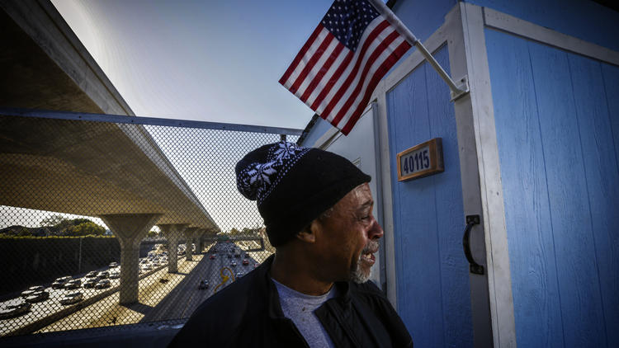
Marvin Burrus, 58, standing next his portable shelter, weeps recalling reasons for being homeless. His portable shelter is parked on 42nd Street bridge above the 110 Freeway in Los Angles.
(Irfan Khan / Los Angeles Times)
The council also voted to create a new fund to hold the $100 million city leaders want to appropriate for homeless programs, though it remains unresolved where that money will come from.
“If this sounds complex and slow, it has been sort of a maddening and frustrating process for all of us,” Bonin said. “We all want to go very, very fast. What we’re trying to do is find ways to go as fast as possible but we keep running into charter requirements, [environmental] requirements and some of our own self-imposed handcuffs.”
In October, the county Board of Supervisors declared a shelter crisis in anticipation of the storms that will come with El Niño. There are concerns that encampments in storm drains and river beds could be flooded when the powerful storm system hits Southern California. Supervisors also increased the number of winter shelter beds from 600 to 861.
Officials did not provide an estimate Tuesday of how many people might be sheltered under the city’s expanded program.
Twitter: @thecitymaven and @geholland
ALSO
On the Streets: An ongoing video series about homelessness in Southern California
Sandy Banks: Compassion, confusion and resentment in a city where the homeless are everywhere
Steve Lopez: A punch in Pauley Perrette's face may be the kick in the pants we need on homelessness

Privacy Policy
Copyright © 2015, Los Angeles Times

UPDATE
9:37 p.m.: This article was updated with additional reaction to the council actions.
2:36 p.m.: This article was updated with additional comments and information about the City Council actions.
This article was first posted at 1:37 p.m.
- Homelessness

- Jose Huizar

- Los Angeles City Council
Sponsored Links
FROM AROUND THE WEB

Facts required for oil field water, not scare tacticsBakersfield.com I Chevron

The Secret Behind The Best Men's ShoesJack Erwin

The 10 Youngest Billionaires In The WorldBankrate

38 Celebs With The Highest IQ’s in HollywoodYour Daily Dish

Thinking of Selling Your Home? Get Rid of GraniteReviewed.com

The World Was Not Ready For The Gown She WoreStyleBistro

by Taboola
- 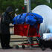

L.A. council declares shelter crisis in effort to help the homeless

Charlie Sheen gives the public an HIV drama, but we may be too numb to his troubles
- 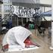

FBI to investigate deadly police shooting of unarmed black Minneapolis man
LOCAL L.A. Now

Activists seek ballot measure for moratorium on L.A. 'mega projects'

David Zahniser
A group of activists said Wednesday that it wants voters to place new limits on real estate "mega developments" by imposing restrictions on projects that need major changes to city planning rules to get built.
The Coalition to Preserve L.A. announced plans for a ballot measure, titled the Neighborhood Integrity Initiative, that would put a moratorium of up to 24 months on development projects that cannot be built without votes from elected officials to increase density.
Read Full Article
LOCAL L.A. Now

450 illegal tamales from Mexico seized at LAX and destroyed

Veronica Rocha
Apparently there are illegal tamales.
A passenger at Los Angeles International Airport learned that the hard way earlier this month when he tried to bring pork tamales into the U.S. from Mexico.
The passenger arrived from Mexico on Nov. 2 and was stopped by U.S. Customs and Border Protection agriculture specialists, who found 450 pork tamales wrapped in plastic bags in the passenger’s luggage.
The passenger apparently denied that the tamales were made with pork, which is forbidden under customs regulations.
Read Full Article
LOCAL L.A. Now

2 LAFD firefighters hurt battling massive home fire in Koreatown

Veronica Rocha
Two firefighters were injured early Wednesday after flames swept through a two-story home in Koreatown and surrounded them, officials said.
The firefighters were tackling flames at about 1:08 a.m. inside the 3,484 square-foot home in the 800 block of South Crenshaw Boulevard when they were briefly trapped by debris, said Brian Humphrey, spokesman for the Los Angeles Fire Department.
As flames surrounded the pair, the first floor, which is over a basement, gave way, he said.
Interested in the stories shaping California?
Read Full Article
LOCAL L.A. Now

Edison blames mismanagement for power outages in Long Beach

Matt Hamilton
Electrical vault explosions that left thousands in Long Beach without power for several days this summer stemmed from a cascade of breakdowns that originated in Southern California Edison's mismanagement, according to two reports released Tuesday by the company.
The vault explosions and outages were set in motion by the failure of a single cable splice -- the point at which two pieces of cable are joined -- according to the company’s internal report, which reached the same conclusions as the external inquiry completed by a consulting firm.
Read Full Article
LOCAL L.A. Now

2 Air France flights to Paris diverted because of bomb threats

Matt Hamilton
Two Paris-bound flights – including one that departed from Los Angeles – were diverted and grounded Tuesday evening because of bomb threats, prompting investigations by local and federal authorities.
The two Air France flights received anonymous bomb threats via telephone after takeoff, and the Paris-based airline decided “as a precautionary measure” to ground both flights and perform security checks, according to a statement provided by the airline.
Air France flight 65 – which departed from Los Angeles International Airport about 3:45 p.m.
Read Full Article
LOCAL L.A. Now

Earthquake: 3.4 quake jolts Inland Empire

Matt Hamilton
A magnitude 3.4- earthquake rattled the Inland Empire on Tuesday evening, but no damage was reported, authorities said.
The temblor struck about 8:41 p.m. and was centered about six miles north of Fontana, near the junction of the 15 and 215 freeways, the U.S. Geological Survey said.
NEWSLETTER: Get the day's top headlines from Times Editor Davan Maharaj >>
The quake, which occurred at a depth of about 6 miles, was felt across a wide swath of the Inland Empire, from parts of Victorville south to Temecula, the USGS said.
Read Full Article
LOCAL L.A. Now

Report on fatal shooting of unarmed black man is sharply critical of Pasadena police

Richard Winton and Corina Knoll
An independent consultant’s report on the 2012 fatal shooting of an unarmed black man by Pasadena police officers sharply faulted the department’s investigation of the controversial killing, as well as the officers’ tactics.
The redacted document was released Tuesday after a yearlong legal battle during which the police officers union fought to keep its contents private.
Kendrec McDade, 19, was shot seven times after a 911 caller falsely reported that the Azusa High graduate was carrying a gun when he and a friend stole a laptop.
Read Full Article

- MOST POPULAR
- LOCAL
- ENTERTAINMENT
- SPORTS
- POLITICS
- CAMPUS UNREST
- OPINION
- PLACE AN AD

68°

